English tittle

Name Surname ¹, Name Surname ², Name Surname ^{2,}*
¹ Affiliation 1; e-mail@e-mail.com
² Affiliation 2; e-mail@e-mail.com
* Correspondent author; e-mail@e-mail.com
Summary: One column and about 200 words. For research articles, abstracts should include an overview of the work. Authors are strongly encouraged to use the following style of structured summaries, but without headings: (1) Background: Put the question raised in a broad context and highlight the purpose of the study; (2) Methods: briefly describe the main methods or treatments used; (3) Results: Summarize the main findings of the paper; and (4) Conclusions: Indicate the main conclusions or interpretations. The abstract should be an objective representation of the article, should not include results that are not presented and substantiated in the main text, and should not exaggerate the main conclusions..
Key words: keyword 1; keyword 2; keyword 3 (Give three to ten relevant keywords specific to the article but fairly common within the field)

0. How to use the template

The template lists the sections that can be used in the manuscript. Note that each section has a corresponding style, which can be found in the "Styles" menu in Word. Sections that are not mandatory are listed as such. The section titles given are for articles. Review articles and other types of articles have a more flexible structure.

Delete this paragraph and start section numbering from 1. If you have any questions, please contact the journal editors.

1. Introduction
The introduction should briefly describe the study in a broad context and highlight why it is important. It should define the purpose of the work and its meaning. The current state of research should be fully known and only key publications should be cited. Highlight controversial and divergent hypotheses as needed. Finally, briefly note the main goal of the work and highlight the main conclusions. If possible, please refer to the introduction for scientists outside the field of research.

2. Materials and method
The method and materials should be described sufficiently to enable others to replicate and exploit published results. Remember that the publication of a manuscript means that you must make available to readers all materials, data, computer code, and protocols associated with it. Any restrictions on the availability of materials or information should be disclosed at the manuscript submission stage. New methods and protocols should be described in detail, while well-known methods may be briefly described and cited appropriately.
Research manuscripts reporting large datasets that are deposited in a publicly accessible database should state where the data has been deposited and provide appropriate access to it.
Interventional studies involving animals or humans and other studies requiring ethical approval must include a list of the authorities that granted the approval and relevant documentation.

2.1. Figures and Tables
All figures and tables should be cited in the text as Figure 1, Table 1, etc. Symbols, signs, words, and numbers in the Figure should be of a size that allows them to be read, preferably not smaller than the signature of the Figure (10 points). References to the Figure and Table written in brackets should be abbreviated "……(Fig. 1)" or "……(Tab. 1)"
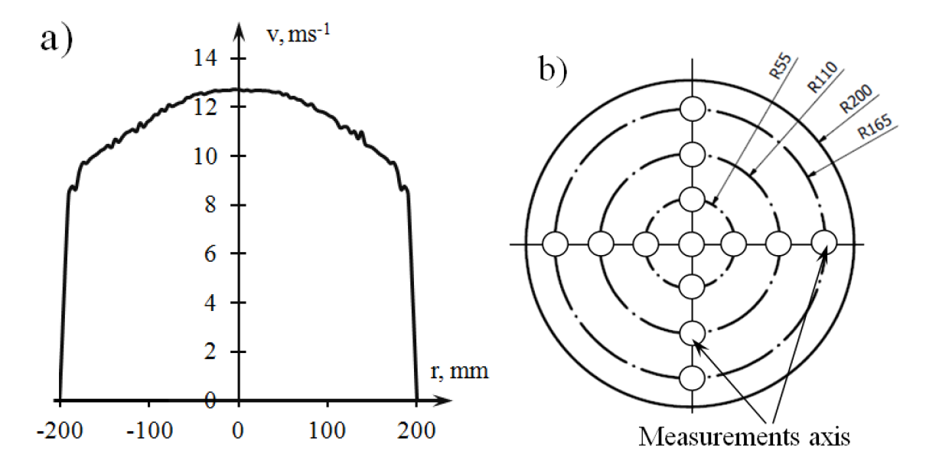
Rys. 1. To jest rysunek. Rysunek powinien zostać umieszczony w głównym tekście po tym jak zacytowano go po raz pierwszy
Fig. 1. This a figure. Figure should be placed in the main text near to the first time they are cited.
The table can be of any format. The text in the table should be written in style ‘1.7 Table inside’.
Table 1. This is a table. Tables should be placed in the main text near to the first time they are cited.
Title 1 | Title 2 | Title 3
entry 1 | data | data
entry 2 | data | data

2.2. Formatting equations
Equations should be aligned to the center and numbered sequentially from the right. Equations should be created using the Insert Equation command built into the MS Office package or using special programs such as MathType:
${\left(x+a\right)}^{n}=\sum_{k=0}^{n}{\left({n \atop k}\right)x^{k}a^{n-k}}$ (1)
all symbols used in the equation should be explained here unless already explained.

3. Wyniki
This section should contain a concise and precise description of the experimental results, their interpretation, as well as the experimental conclusions that can be drawn.

4. Discussion
The authors should discuss the results and how to interpret them in the perspective of previous research and working hypotheses. Findings and their implications should be discussed in as broad a context as possible. Future research directions can also be identified.

5. Summary
This section is not mandatory, but may be added to the manuscript if the discussion is unusually long or complex.
Acknowledgments: In this section, you can acknowledge any support provided that is not covered by the author's contributions or funding sections. This may include administrative and technical support, donations and funding such as grants.

Attachment A
Attachments are optional. They should contain details and supplementary data to the main text. For example, explanations of details of an experiment that would make the main text difficult to read, but nevertheless remain essential to understanding and reproducing the research presented; replicate drawings for experiments whose representative data are presented in the main text may be added here, if concise, or as supplementary data. Mathematical proofs of results that are not essential to the work can also be added as an attachment.
Annexes should be numbered with successive letters of the Latin alphabet, and Figures and Tables should be numbered as: Figure A1, Figure A2, etc.

References
Citations must be numbered in the order they appear in the text (including quotations in tables and legends) and listed separately at the end of the manuscript. We recommend that you prepare your bibliography using a bibliography software package such as EndNote, ReferenceManager or Mendeley to avoid typing errors and duplicate entries. Include a Digital Object Identifier (DOI) for all references, if available. For English titles, please use abbreviated titles (Journal Abbreviations)
Links to websites are acceptable, but must include the full address and date of access.
Citation numbers in the text should be placed in square brackets [] and placed before the punctuation mark; for example, [1], [1-3], or [1,3].

- Podolski, J. Transport w miastach (ang. Transport in the cities); Wydawnictwo Komunikacji i Łączności: Warsaw, 1985;
- Zhai, H.; Cui, L.; Nie, Y.; Xu, X.; Zhang, W. A Comprehensive Comparative Analysis of the Basic Theory of the Short Term Bus Passenger Flow Prediction. Symmetry (Basel). 2018, 10, 369, doi:10.3390/sym10090369.
- Guo, J.; Xie, Z.; Li, Q.; Zhan, S.; Xu, J. Railway Passenger Flow Recognition Algorithm for Terminal Station Based on Cost Theory and Automatic Frequency Control. IEEE Access 2020, 8, 26885–26892, doi:10.1109/ACCESS.2020.2968721.
- Urban Transport Enthusiasts Club, Konstal 105Na #2566,#2567, Available online: https://kstm.pl/en/105na-opis.html (accessed on Apr 18, 2023).

